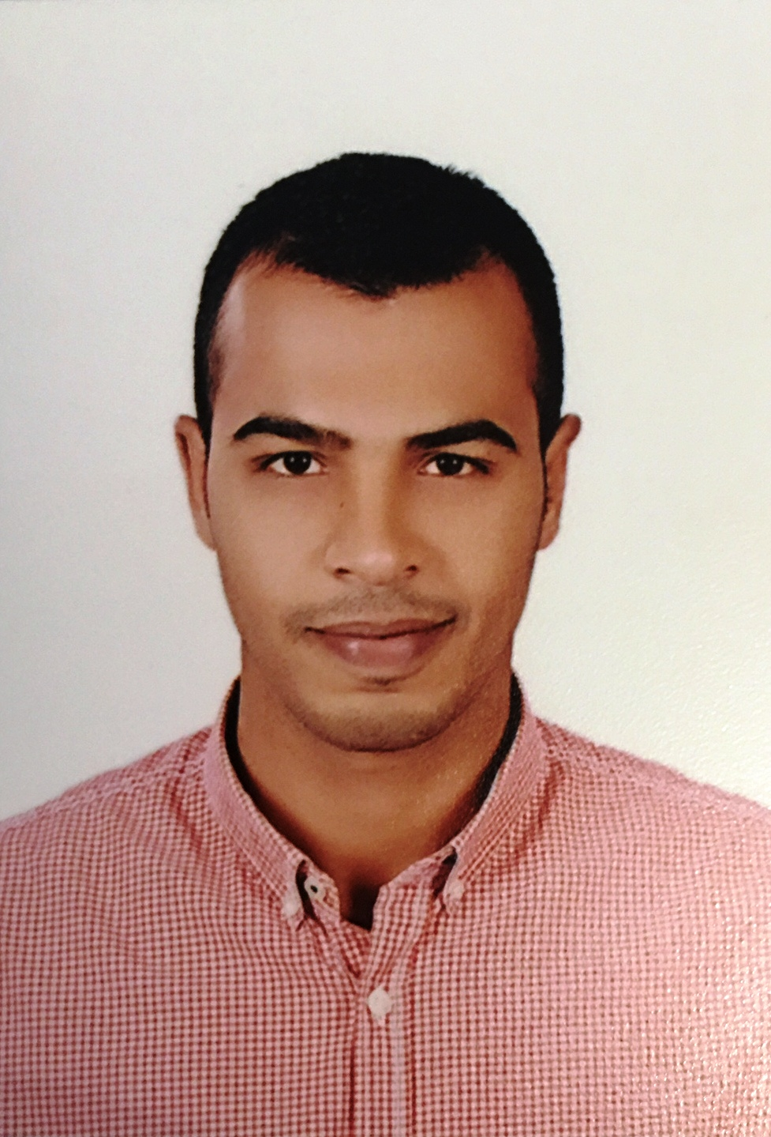
C.V
NAME : Abdelhamed Mohamed Ali
Address : Egypt – Red sea – Hurghada
Date of Birth : 31/12/1992
Mobile : 01069351269
Emile address : mido_mohamed200@yahoo.com
Nationality : Egyptian
Marital status : Single
Military status : Exempted
Religion : Muslim
Position : Floor man
Object : Challenging work as drilling worker . detail oriented with priority of people and their team work . an eye for the bottom line and record of success
Qualification
Bachelor of Management and information system (2013)
Experiences
1-worked with star Nile Drilling Company
Position: roustabout
From 25/12/2011 to 3/3/2014
2-worked with petro drilling Company
Position: Floor man
From 1/4/2014 to 1/5/2017
Training and certification
- IADC WELLSHARP ( Subsea/Surface) certificate Number (29212312700197-25FC1B)
- H2S
- Fie fighting
- First Aid
Skills
- Computer: excellent at using Excel ,word and accounting system
- Team player
- Hard worker
- Good communication
- Work under stress
- Ambitious – self learner
Languages
- Arabic : native language
- English : very good ( speaking and reading ) AUC course level 4
Essential function
I work in a safe , healthy and environmentally protective manager . assistant driller , derrick hand and motor hand while rigging up , nippling up tearing out and rig maintenance while drilling
knows how to operate power tong during connection
I work prepare floor before trip , connection
I work out housekeeping task around rig such as washing and painting either on own initiative or as assigned
I catches samples , dig and clean ditches , shovels shale
Reference
I will be pleased to provide upon request

